

Practices for Secure Software Report

Table of Contents
Document Revision History 3
Client 3
Instructions 3
Developer 4
1. Algorithm Cipher 4
2. Certificate Generation 4
3. Deploy Cipher 4
4. Secure Communications 4
5. Secondary Testing 4
6. Functional Testing 4
7. Summary 4
8. Industry Standard Best Practices 4

Document Revision History

Version | Date | Author | Comments
1.10 | June 9, 2026 | Ken Custer | Final completed draft

Client



Developer

Ken Custer

Algorithm Cipher

For Artemis Financial, I would recommend AES-256 as the encryption cipher for protecting sensitive financial data. AES is a symmetric encryption algorithm, which means the same secret key is used to encrypt and decrypt the data. I chose AES-256 as the recommended cipher because it is strong, widely used, and appropriate for protecting financial information when the key is handled correctly.

For the checksum part of this project, I used SHA-256. SHA-256 is a cryptographic hash algorithm that takes input data and creates a fixed 256-bit hash value. I chose it because Artemis Financial needs a way to check whether data has changed during transfer or processing. NIST explains that secure hash algorithms create message digests that can help detect when a message has changed after the digest was created (National Institute of Standards and Technology [NIST], 2015). That fits this assignment because the same data string should create the same checksum each time. If the data is changed, the checksum should also change.

SHA-256 is part of the SHA-2 family. It is important to point out that SHA-256 is not encryption like AES. AES is used to encrypt and decrypt data, while SHA-256 is a one-way hash function. In this project, I used SHA-256 for integrity, not confidentiality. Since the hash is not reversed back into the original data, the checksum process does not use symmetric keys or asymmetric keys. It also does not use random numbers for the basic checksum because the output needs to stay consistent when the same input is used.

Random numbers are more important when encryption is being used. For example, AES should use a proper random value such as an initialization vector or nonce when the mode of operation requires it. That helps keep repeated data from producing predictable encrypted output. SHA-256 does not use random numbers for the basic checksum in this project because the same input needs to create the same hash value each time.

Older encryption and hash algorithms are not always the best choice for modern applications. Algorithms such as DES are considered outdated because their key sizes are too small for current security needs. Older hash algorithms such as MD5 and SHA-1 were used more often in the past, but they are weaker now because of known security issues and collision concerns. I chose SHA-256 for the checksum because it is stronger than those older hash options and is still commonly used for integrity checking.

For Artemis Financial, the checksum does not hide the data by itself. Instead, it gives the application a way to check whether data has been changed. Since this is a financial application, even a small change in data could cause problems with records, calculations, or customer trust. AES-256 would support confidentiality, while SHA-256 supports integrity. Together, those ideas help add another layer of security to the application.

Certificate Generation

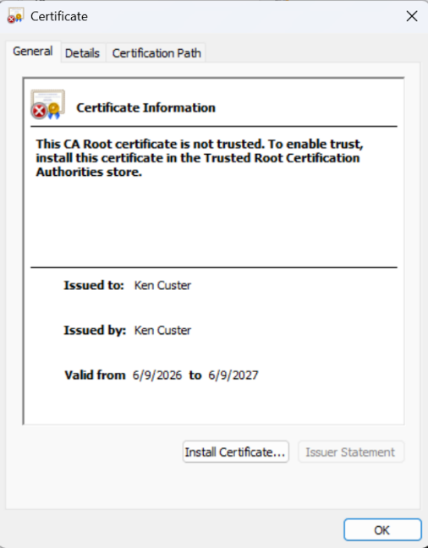

I generated a self-signed certificate with the Java Keytool and used it with the Spring Boot application. The certificate was stored in a PKCS12 keystore. I used the alias artemis, and I connected the keystore to the application through the SSL settings in the application properties file.

The Keytool command created the keystore file and assigned the alias. I also exported the certificate as a CER file and included a screenshot of it in the report. This showed that the certificate was actually created and not just described. It also showed that the certificate was tied back to the application through the keystore settings.

A self-signed certificate is acceptable for this assignment because I was testing the application locally. In a real production environment, Artemis Financial should use a certificate from a trusted certificate authority. That would allow browsers and users to verify that the server really belongs to Artemis Financial.

When I tested the page, the browser still showed a warning because the certificate was self-signed. I did not treat that as a failed HTTPS test because the page still loaded through the HTTPS address and used the keystore settings from the application properties file. The warning was about trust, not about whether HTTPS was configured.

This added another security layer because the application was no longer relying on plain HTTP communication. The certificate and keystore allowed the application to use SSL/TLS locally, which helped protect the connection between the browser and the server. Even though the certificate was self-signed for this project, generating and applying it still showed the process Artemis Financial would need before moving to a trusted certificate in a production environment.

Deploy Cipher

I refactored the application by adding a /hash route. When I opened that route in the browser, it displayed my name, my unique data string, the SHA-256 algorithm, and the generated checksum. This showed that the hash algorithm was actually implemented in the application.

In the code, I used the MessageDigest class to create the SHA-256 hash. The data string was converted into bytes, processed by SHA-256, and then converted into a hexadecimal string. The hex string is what appears in the browser because it is much easier to read and compare than raw byte output.

The checksum supports integrity checking. If the original data string changes, the SHA-256 output should also change. That gives the application a way to tell that the data is no longer the same as what was expected.

For Artemis Financial, this is useful because financial data needs to stay accurate. The checksum is not the only security control the application needs, but it adds a way to verify that data has not been changed.

I also kept the checksum implementation focused on integrity instead of trying to make it do more than it was supposed to do. The purpose of this route was not to hide the data, but to create a reliable value that could be compared later. If the data string changed, even by one character, the SHA-256 checksum would change. That is important for Artemis Financial because financial records need to stay accurate, and the company needs a way to detect when information may have been changed.

Using Java’s built-in MessageDigest class also helped keep the refactoring simple. I did not need to add another outside library just to create the hash. This reduced the chance of adding another dependency problem while still meeting the checksum requirement.

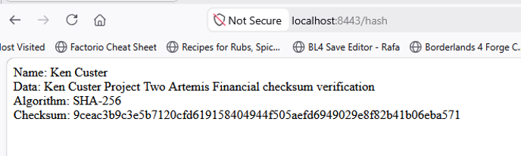

Secure Communications

I updated the application properties file so the application would run over HTTPS instead of HTTP. I set the server to use port 8443 and pointed the SSL settings to the keystore file. Spring Boot uses the server.ssl.* settings in the application properties file for this type of HTTPS setup, including the keystore location and password (Webb et al., 2020).

After starting the application, I tested it by opening https://localhost:8443/hash in the browser. The page loaded and showed the checksum information. That verified that the /hash route worked through the HTTPS address required for the assignment.

The browser showed “Not Secure” because my certificate was self-signed. That was expected for a local self-signed certificate. The important part for this assignment was that the application loaded through HTTPS on port 8443 and used the keystore settings I configured.

Using HTTPS is important because financial information should not be sent over plain HTTP. HTTPS adds protection while data moves between the client and server. For Artemis Financial, that is one of the basic security layers needed for a financial application.

This change addressed the communication layer of the application. Before this refactoring, the application could be reached through regular HTTP, which does not provide the same protection for data moving between the client and server. By changing the application properties file and running the application through https://localhost:8443/hash, I verified that the secure route was being used.

This matters for Artemis Financial because financial applications should not rely on plain-text communication. Even though this was a local test with a self-signed certificate, it still demonstrated the correct process of moving the application toward HTTPS. In a real environment, Artemis Financial would use a trusted certificate authority, but the local test showed that the application was configured to support secure communication.



Secondary Testing

After I made the code changes, I ran OWASP Dependency-Check as the secondary static test. The reason for running it again was to check whether my refactoring introduced any new dependency-related issues. OWASP describes Dependency-Check as a software composition analysis tool that checks project dependencies for publicly disclosed vulnerabilities (OWASP Foundation, n.d.).

The scan completed, and the build finished without errors. I reviewed the report after the refactoring. The report still showed vulnerable dependencies, but those were part of the existing project dependency findings. I did not add a new outside library for the checksum route, so the refactoring itself did not add a new dependency problem.

For this project, I reviewed the Dependency-Check results after the refactoring to make sure my code changes did not create a new dependency issue. The remaining findings were connected to the project’s existing libraries, not to the SHA-256 checksum route or the HTTPS settings I added. I also reviewed the results for possible false positives and used the scan as part of my secondary testing process.

This step was important because just seeing the application run in the browser does not prove the project is secure. The browser test showed that the route worked, but Dependency-Check gave me another way to look at the project after the changes were made.

This step also helped separate issues caused by my refactoring from issues that were already present in the original project. Since I did not add a new outside dependency for the checksum route, the scan helped confirm that my added code did not create a new dependency risk. If the scan had shown a new vulnerability caused by my changes, I would have needed to go back, adjust the code or configuration, and run the test again until the new issue was resolved.

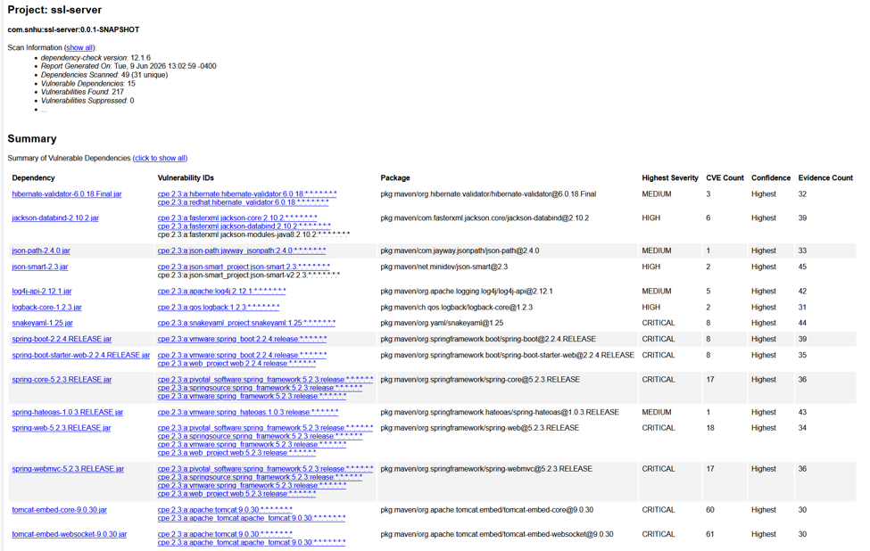

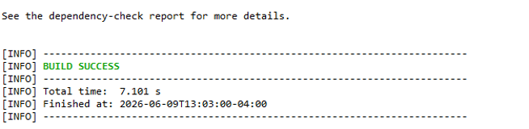

Functional Testing

I manually reviewed the refactored application for syntax, logic, and security issues. For syntax, I checked that the Java code compiled and that the application started without errors. I also checked that the /hash route was written correctly and that the required imports for MessageDigest, StandardCharsets, and NoSuchAlgorithmException were included.

For logic, I tested the /hash route in the browser and verified that it displayed my name, the unique data string, the SHA-256 algorithm, and the checksum. I also checked that the checksum was created from the intended data string and displayed as a hexadecimal value. This helped confirm that the route was doing what it was supposed to do instead of only loading a blank or incorrect page.

For security, I reviewed the application properties file and confirmed that the application was using HTTPS settings instead of plain HTTP. I checked the port, keystore file, alias, password, and keystore type. I also tested the route through https://localhost:8443/hash to confirm that the page loaded through the secure local address.

The application compiled and ran without errors, and the Dependency-Check scan completed after the refactoring. These checks helped confirm that the code changes did not break the application and that the checksum route and HTTPS configuration worked in the running project. By checking the code, configuration file, browser output, HTTPS route, and dependency scan, I was able to test the refactored application from more than one angle.

The functional testing showed that the application still worked after I made the security changes. The project compiled without errors, the application started, and the /hash route loaded in the browser. The page displayed my name, my data string, the SHA-256 algorithm, and the checksum instead of showing a blank page or an error.

I also tested the route through https://localhost:8443/hash to make sure the application was using the HTTPS setup. The browser warning was expected because the certificate was self-signed, but the page still loaded through HTTPS on port 8443. These checks helped me confirm that the refactoring did not break the application and that the security changes were actually working in the running project.

This manual review helped me look at the application from more than one direction. The syntax review showed that the code compiled and the needed imports were present. The logic review showed that the /hash route created the expected SHA-256 checksum from the intended data string. The security review showed that the application was using the HTTPS settings and keystore configuration instead of only running through regular HTTP.

I also treated the testing as an iterative process. If the application had failed to compile, the /hash route had not loaded, the checksum had been blank, or the Dependency-Check scan had shown a new issue from my changes, I would have needed to correct the problem and test again. Since the application compiled, ran, displayed the checksum, loaded through HTTPS, and completed the secondary scan, I was able to confirm that the refactored code worked without breaking the existing application.

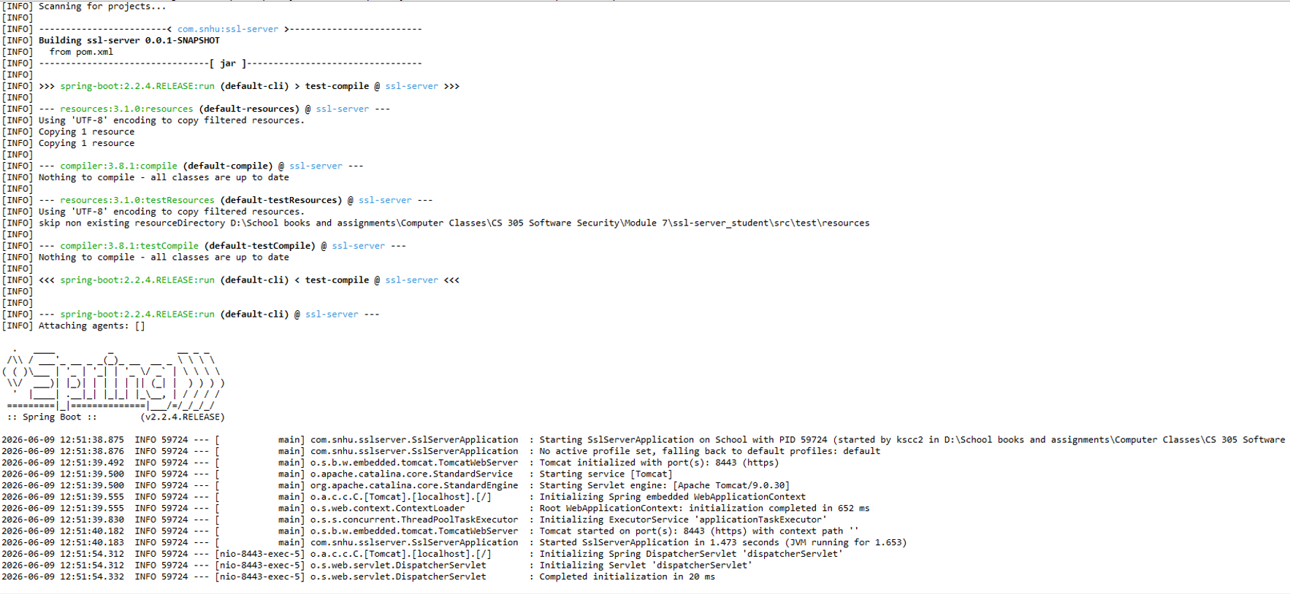

Summary

I refactored the Artemis Financial application by adding a SHA-256 checksum route and configuring HTTPS communication. The /hash route creates a checksum from a unique data string. The HTTPS configuration allows the application to run on port 8443 using the self-signed certificate and keystore.

The main security areas I addressed were data integrity and secure communication. The checksum helps check whether data has changed. HTTPS helps protect data while it is being sent between the client and server. These were the main areas of the vulnerability assessment process that applied to my refactoring.

The changes added more than one layer of security. SHA-256 supports integrity checking, HTTPS supports secure communication, the certificate supports the SSL/TLS setup, and Dependency-Check supports dependency review. I also manually tested the application after the changes instead of assuming the refactoring worked.

After the refactoring, I confirmed that the application compiled, the /hash route worked, the browser showed the checksum output, and the secondary static scan completed. This process helped show that the application was changed and then tested again.

Overall, the refactoring improved the application by adding checksum verification and HTTPS communication. It also followed the expected testing process by combining manual review, browser testing, and static dependency testing.

I also included the supporting code and configuration files as attachments with the completed report. These include the Java file that contains the /hash route, the application.properties file that shows the HTTPS and keystore settings, the certificate or keystore evidence, and the OWASP Dependency-Check report from the secondary scan. I included these because they show the actual changes I made instead of only explaining them in the report.

Together, the report and attachments show that I added the checksum route, configured HTTPS, tested the application in the browser, and ran the secondary dependency scan after the refactoring.

Industry Standard Best Practices

I applied secure coding best practices by using SHA-256 instead of weaker hash algorithms such as MD5 or SHA-1. I also configured HTTPS instead of leaving the application on plain HTTP. These choices helped add security without removing the application’s existing functionality.

I also used manual code review and OWASP Dependency-Check after the refactoring. Manico and Detlefsen (2014) explain that Java applications often rely on third-party libraries and frameworks, and those libraries can contain known vulnerabilities. That applies to this project because Artemis Financial’s application uses outside dependencies that still need to be reviewed.

Another best practice I used was testing after making security changes. Adding the /hash route would not be enough if the route failed when the application ran. Setting up HTTPS would not be enough if the secure URL did not load. Testing helped confirm that the changes worked in the actual running application.

These practices have value for Artemis Financial because they reduce risk and help protect customer information. Stronger hashing, HTTPS, manual review, and dependency scanning all support a better security posture. They also help protect the company’s reputation because customers expect financial applications to handle data carefully.

Secure coding also helps prevent bigger problems later. It is usually easier to find and fix issues during development than after the application is already released. For that reason, using secure coding practices helps both the software and the company.

I also tried to keep the security changes focused and controlled. I did not add unnecessary outside libraries for the checksum route because that could have increased the attack surface of the application. Instead, I used Java’s built-in MessageDigest class for SHA-256. This helped keep the application simpler while still meeting the checksum requirement. Keeping security changes as simple as possible is important because every added dependency, setting, or feature can create another area that has to be tested and maintained.

References
Manico, J., & Detlefsen, A. (2014). Iron-clad Java: Building secure web applications. McGraw Hill Education.

National Institute of Standards and Technology. (2015, August). Secure hash standard (SHS) (FIPS PUB 180-4). U.S. Department of Commerce. https://doi.org/10.6028/NIST.FIPS.180-4

OWASP Foundation. (n.d.). OWASP Dependency-Check. https://owasp.org/www-project-dependency-check/

Webb, P., Syer, D., Long, J., Nicoll, S., Winch, R., Wilkinson, A., Overdijk, M., Dupuis, C., Deleuze, S., Simons, M., Pavić, V., Bryant, J., & Bhave, M. (2020). Spring Boot reference documentation. Spring. https://docs.spring.io/spring-boot/docs/2.2.4.RELEASE/reference/htmlsingle/

